MEDICINE USAGE AND SIDE EFFECT ANALYSIS
MINI PROJECT RECORD
Name: _______________________ Register No.: _______________________
Department of Artificial Intelligence and Machine Learning

1. AIM
To combine four medicine-related sample datasets, clean and preprocess the data, study medicines, diseases, reported reactions, age, gender, country and manufacturers, and present the findings using Matplotlib, Seaborn, Power BI and Tableau.
Dataset note: The four supplied CSV files contain synthetic demonstration records based on the structure of Medicine Details, FDA Labels, FDA adverse-event reports and OECD consumption data. Results do not describe actual patient populations or national usage.

2. ALGORITHM
1. Start the program and import Pandas, NumPy, Matplotlib and Seaborn.
2. Read the four CSV files: medicine details, drug labels, adverse-event reports and country-wise consumption.
3. Remove duplicate records and unnecessary spaces.
4. Convert age into numerical form and mark invalid/missing age values as Unknown.
5. Create age groups: 0–17, 18–39, 40–59 and 60+.
6. Merge medicine details and label information using medicine_name.
7. Join country/class/year consumption values as background information, not as an individual drug usage count.
8. Save the cleaned combined data as a CSV file.
9. Draw three charts using Matplotlib and three charts using Seaborn.
10. Create separate Power BI and Tableau dashboard layouts.
11. Stop.

3. CODE

3.1 Preprocessing code
File: preprocessing_only.py. Keep this file in the same folder as the four source CSV files.
from pathlib import Path
import pandas as pd
import numpy as np

OUT = Path(__file__).resolve().parent
# Read and preprocess all four independently.
a=pd.read_csv(OUT/'source_1_medicine_details_SAMPLE.csv').drop_duplicates('medicine_name')
b=pd.read_csv(OUT/'source_2_fda_labels_SAMPLE.csv').drop_duplicates('medicine_name')
c=pd.read_csv(OUT/'source_3_fda_events_SAMPLE.csv').drop_duplicates('report_id')
d=pd.read_csv(OUT/'source_4_oecd_consumption_SAMPLE.csv').drop_duplicates(['country','drug_class','year'])
for frame in (a,b,c,d):
for col in frame.select_dtypes(include='object'):
frame[col]=frame[col].str.strip()
c['patient_age']=pd.to_numeric(c['patient_age'],errors='coerce')
c.loc[~c.patient_age.between(0,110),'patient_age']=np.nan
c['age_group']=pd.cut(c.patient_age, bins=[-1,17,39,59,110], labels=['0-17','18-39','40-59','60+'])
c['age_group']=c['age_group'].astype('object').fillna('Unknown')
c['gender']=c.gender.fillna('Unknown')
# Label and medicine information matched by normalized medicine name in the demo.
combined=c.merge(a,on='medicine_name',how='left',validate='many_to_one')
combined=combined.merge(b,on='medicine_name',how='left',validate='many_to_one')
# Country-class-year consumption is a CONTEXT METRIC, not patient-specific use.
combined=combined.merge(d,left_on=['country','drug_class','report_year'],right_on=['country','drug_class','year'],how='left',validate='many_to_one')
combined['indication']=combined.label_indication.fillna(combined.uses).fillna(combined.reported_indication)
combined['manufacturer']=combined.manufacturer.fillna(combined.label_manufacturer).fillna('Unknown')
keep=['report_id','medicine_name','indication','drug_class','manufacturer','country','patient_age','age_group','gender','reported_reaction','known_side_effect','report_year','consumption_ddd_per_1000_per_day','data_origin']
combined=combined[keep].rename(columns={'reported_reaction':'reported_side_effect'})
combined.to_csv(OUT/'combined_medicine_analytics_SAMPLE.csv',index=False)
print('Combined rows:', len(combined))
print('Combined columns:', len(combined.columns))
print('Missing age values:', combined.patient_age.isna().sum())
print('Countries:', combined.country.nunique())
print('Manufacturers:', combined.manufacturer.nunique())
print(combined.head(5).to_string(index=False))

3.2 Visualization code — Matplotlib and Seaborn
File: visualization_only.py. Run after preprocessing. The program saves all six chart images.
from pathlib import Path
import pandas as pd
import matplotlib
matplotlib.use('Agg')
import matplotlib.pyplot as plt
import seaborn as sns
OUT = Path(__file__).resolve().parent
combined = pd.read_csv(OUT/'combined_medicine_analytics_SAMPLE.csv')
d = pd.read_csv(OUT/'source_4_oecd_consumption_SAMPLE.csv')

sns.set_theme(style='whitegrid',font_scale=.9)
def save(name):
plt.tight_layout();plt.savefig(OUT/name,dpi=160,bbox_inches='tight');plt.close()
# Matplotlib 1: report counts for medicines
v=combined.medicine_name.value_counts().head(10).sort_values()
plt.figure(figsize=(8,4));plt.barh(v.index,v.values,color='#3D7A9F');plt.title('Top 10 medicines by sample report count');plt.xlabel('Sample reports');save('matplotlib_1_medicines.png')
# Matplotlib 2: age groups
v=combined.age_group.value_counts().reindex(['0-17','18-39','40-59','60+','Unknown'],fill_value=0)
plt.figure(figsize=(7,4));plt.bar(v.index,v.values,color='#5C9E8A');plt.title('Sample reports by patient age group');plt.ylabel('Sample reports');save('matplotlib_2_age.png')
# Matplotlib 3: gender
v=combined.gender.value_counts();plt.figure(figsize=(6,4));plt.pie(v.values,labels=v.index,autopct='%1.1f%%',colors=['#477B9E','#E5AD62','#AEB3B8']);plt.title('Gender share of sample reports');save('matplotlib_3_gender.png')
# Seaborn 1: reported reactions
v=combined.reported_side_effect.value_counts().head(10)
plt.figure(figsize=(8,4));sns.barplot(x=v.values,y=v.index,color='#568BB0');plt.title('Most frequent reactions in sample reports');plt.xlabel('Sample reports');save('seaborn_1_reactions.png')
# Seaborn 2: country-class sample report heatmap (NOT medicine consumption)
top=combined.country.value_counts().head(8).index
pivot=pd.crosstab(combined.loc[combined.country.isin(top),'country'],combined.loc[combined.country.isin(top),'drug_class'])
plt.figure(figsize=(11,5));sns.heatmap(pivot,cmap='Blues',annot=True,fmt='d',cbar_kws={'label':'Sample reports'});plt.title('Country and drug class: sample report counts');save('seaborn_2_heatmap.png')
# Seaborn 3: actual numeric OECD-style metric from synthetic input (not patient counts)
plt.figure(figsize=(9,4));dd=d[d.drug_class.isin(['Analgesic','Antidiabetic','Antibiotic'])];sns.boxplot(data=dd,x='drug_class',y='consumption_ddd_per_1000_per_day',color='#81B7AA');plt.xlabel('Drug class');plt.ylabel('Synthetic DDD per 1,000 people per day');plt.title('Country distribution of synthetic consumption estimates');save('seaborn_3_consumption.png')

4. OUTPUT

4.1 Preprocessing output
The following summary and first five rows were obtained from the supplied demonstration CSVs.
Input medicine records: 18
Input labels: 18
Input event reports: 1600
Input country-class-year records: 90
Combined rows: 1600
Combined columns: 14
Missing age values: 88
Countries: 10
Manufacturers: 5
Data authenticity: SYNTHETIC DEMONSTRATION (not real patient reports)

PREVIEW
report_id medicine_name indication drug_class manufacturer country patient_age age_group gender reported_side_effect known_side_effect report_year consumption_ddd_per_1000_per_day data_origin
DEMO-00001 Fluoxetine Depression Antidepressant Northstar Pharma Canada 43.0 40-59 Female Dizziness Nausea 2024 25.76 SYNTHETIC DEMO
DEMO-00002 Insulin Diabetes Antidiabetic Global Health Italy 88.0 60+ Male Nausea Hypoglycemia 2024 32.02 SYNTHETIC DEMO
DEMO-00003 Fluoxetine Depression Antidepressant Northstar Pharma United States 66.0 60+ Female Fatigue Nausea 2024 33.81 SYNTHETIC DEMO
DEMO-00004 Loratadine Allergy Antihistamine Global Health Spain 70.0 60+ Male Fatigue Headache 2024 84.47 SYNTHETIC DEMO
DEMO-00005 Salbutamol Asthma Respiratory LifeCare Labs France 57.0 40-59 Female Fatigue Tremor 2024 88.22 SYNTHETIC DEMO

4.2 Matplotlib visualization output

Matplotlib — Chart 1
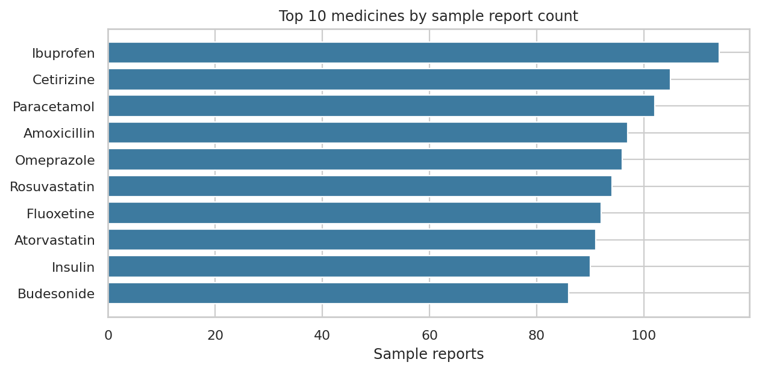
Top 10 medicines by number of sample adverse-event reports.

Matplotlib — Chart 2
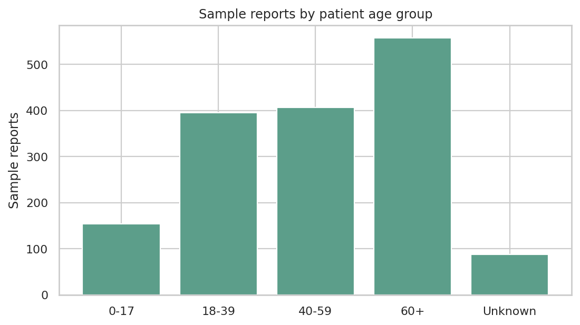
Sample adverse-event reports by age group.

Matplotlib — Chart 3
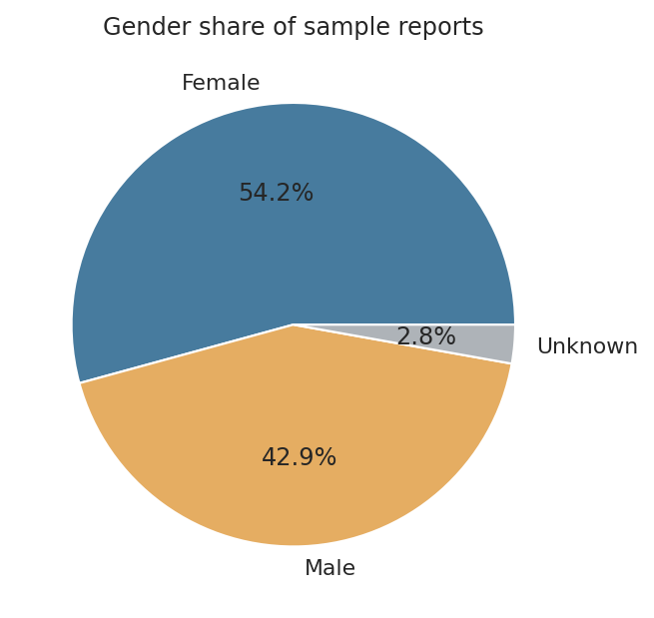
Gender distribution of sample adverse-event reports.

4.3 Seaborn visualization output

Seaborn — Chart 1
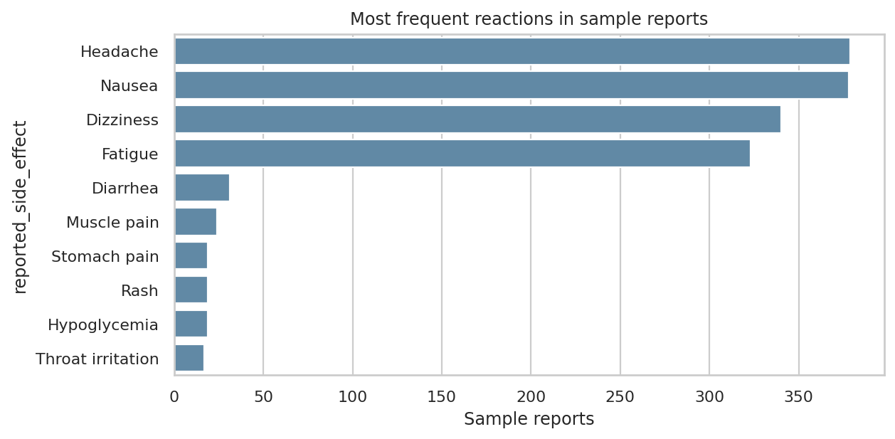
Most frequent reported reactions in sample event reports.

Seaborn — Chart 2
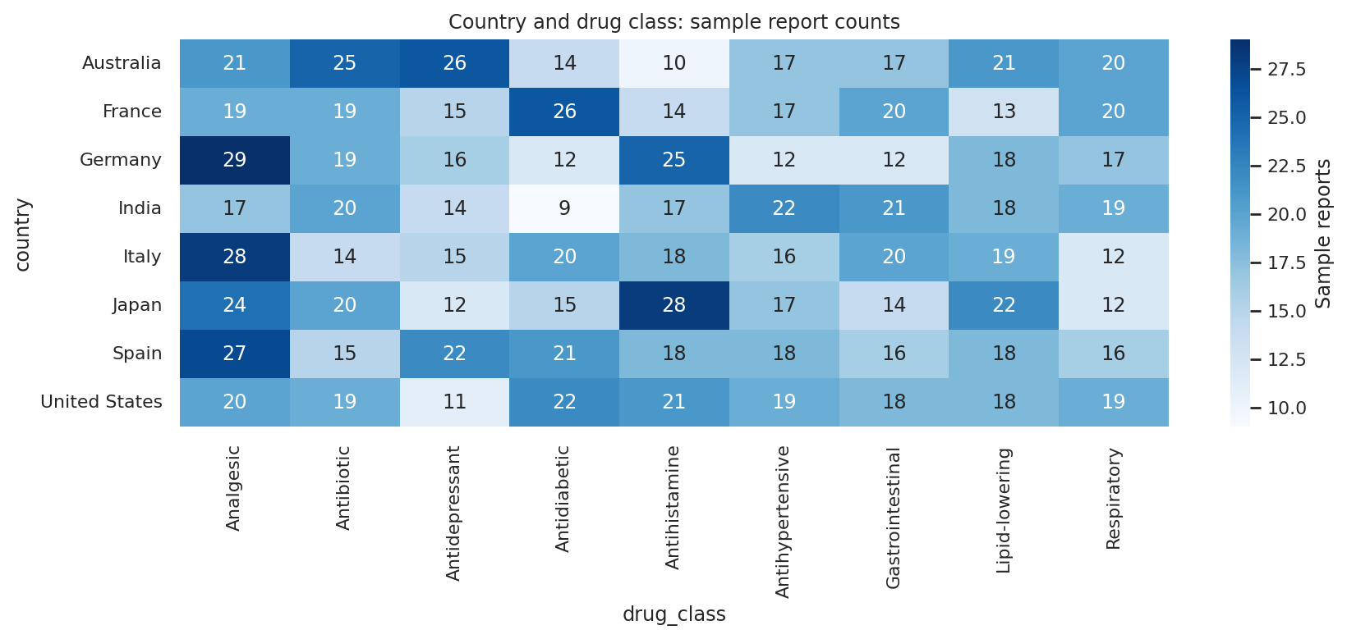
Country-wise sample report counts across drug classes.

Seaborn — Chart 3
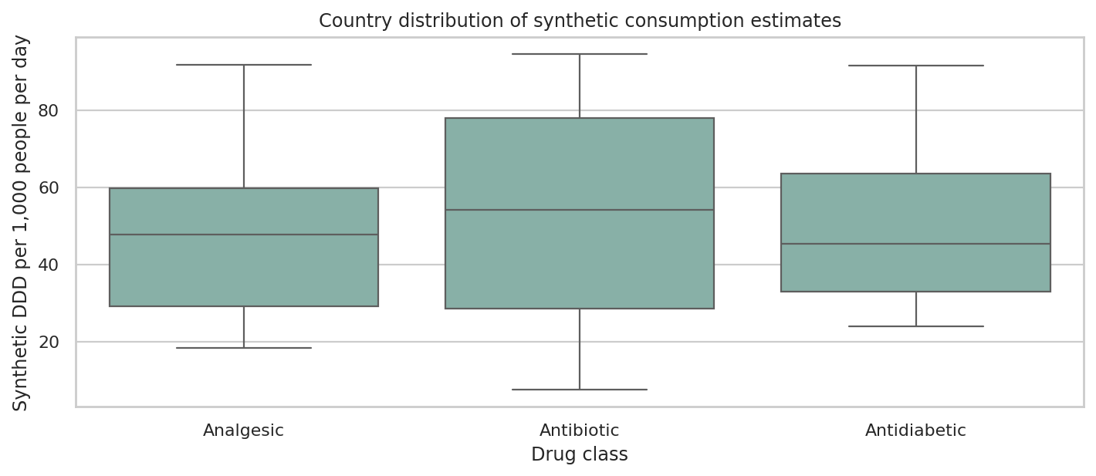
Illustrative distribution of country-level DDD consumption by drug class.

5. POWER BI DASHBOARD
Dashboard design prepared using the combined CSV. This is a dashboard mockup for project presentation; recreate the visuals in the respective desktop application.
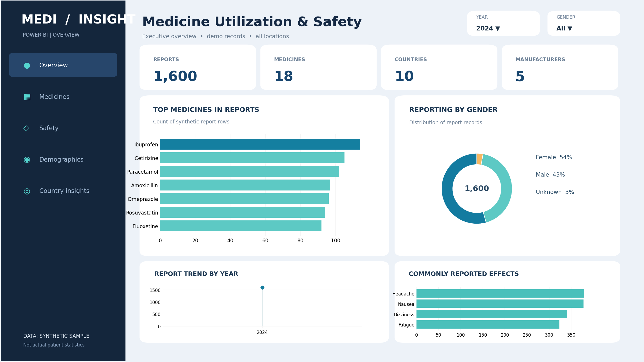
Steps: Power BI Desktop → Home → Get Data → Text/CSV → choose combined_medicine_analytics_SAMPLE.csv → Load. Add Cards for count of distinct reports, medicines, countries and manufacturers. Add a bar chart for indications, a gender pie chart and country column chart. Add medicine and age filters, then align visuals.

Power BI DAX measures
Total Reports = DISTINCTCOUNT(Medicine[report_id])
Total Medicines = DISTINCTCOUNT(Medicine[medicine_name])
Total Countries = DISTINCTCOUNT(Medicine[country])
Total Manufacturers = DISTINCTCOUNT(Medicine[manufacturer])

6. TABLEAU DASHBOARD
Dashboard design prepared using the combined CSV. This is a dashboard mockup for project presentation; recreate the visuals in the respective desktop application.
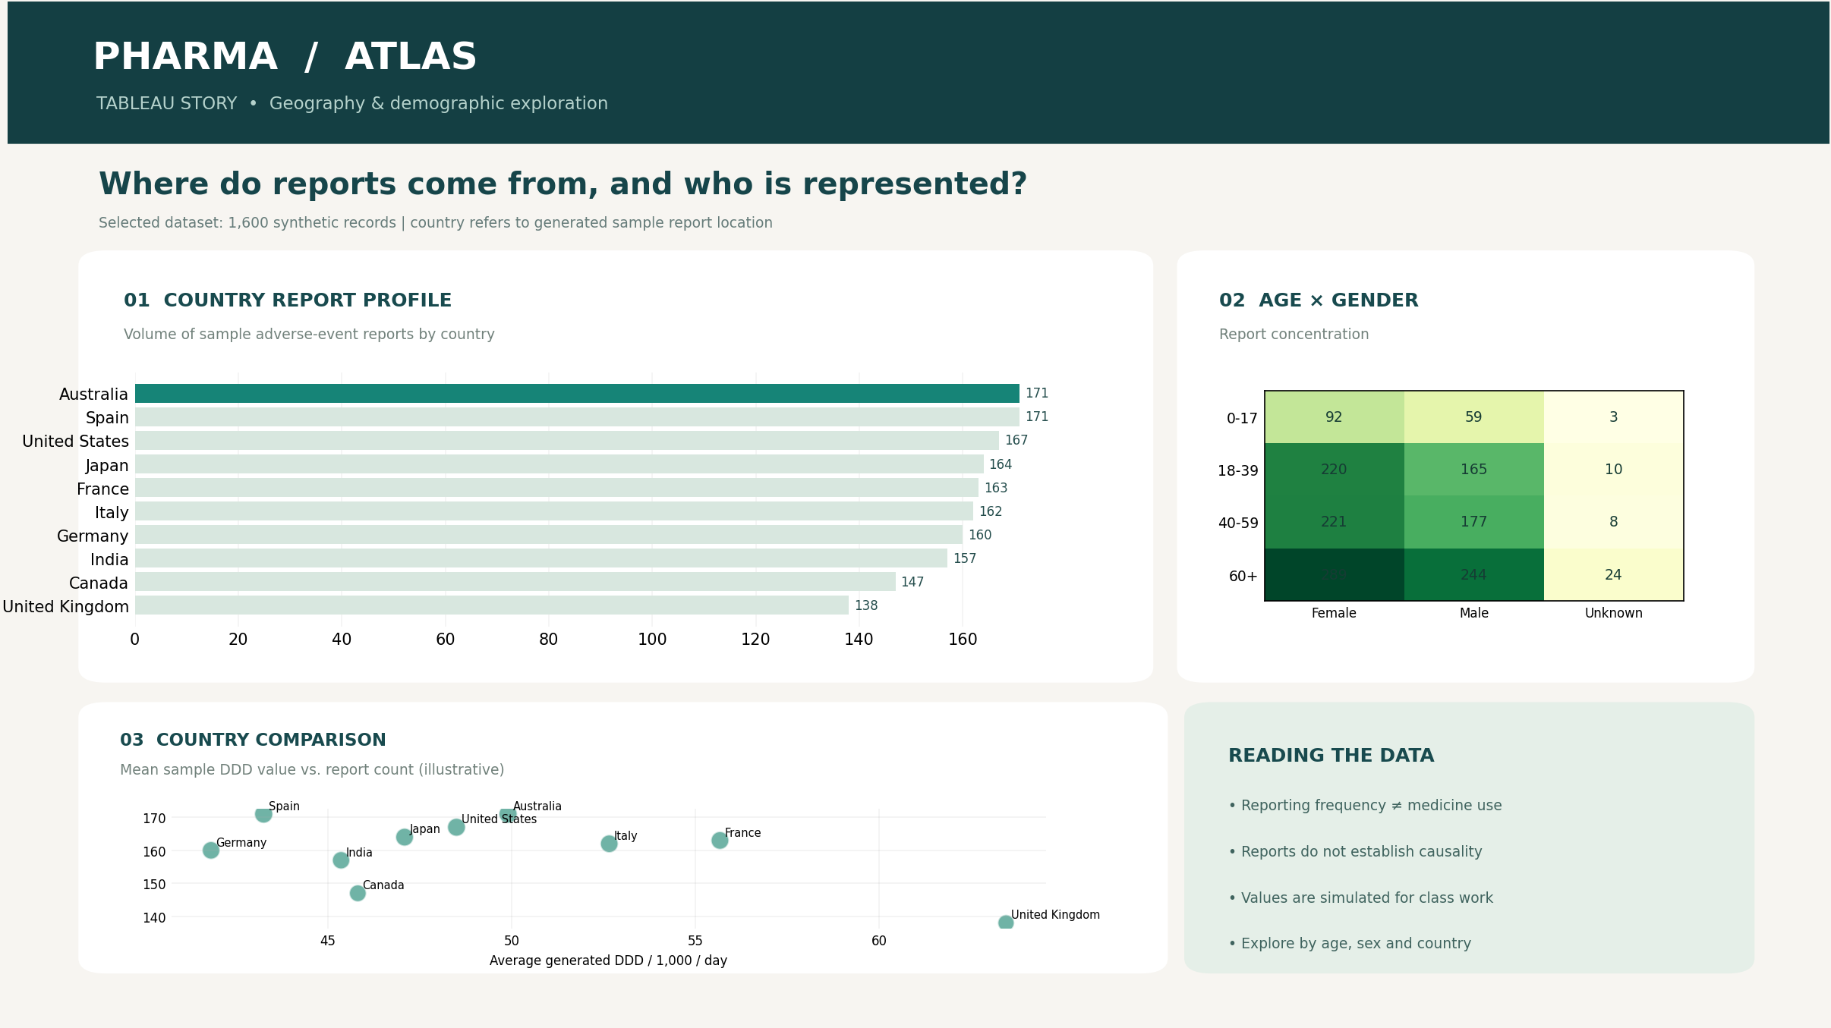
Steps: Connect to the provided CSV in Tableau. Build a country-wise horizontal bar chart, an age-by-gender highlight table, and a country comparison scatter plot. Arrange the three sheets as shown in the Tableau dashboard design.

7. RESULT
Four demonstration source tables were combined into one dataset of 1,600 rows and 14 columns. Three Matplotlib graphs, three Seaborn graphs and two dashboard layouts were prepared. The activity shows how data from multiple sources can be cleaned, merged and visualized.
Note: Report counts do not mean the most used medicine, nor do reports prove a side effect was caused by that medicine. Country-level consumption figures are separate from the safety reports.

